Nandida Valsaraj   
  
2.

Wireless LAN adapter Wi-Fi:

Connection-specific DNS Suffix . :

IPv6 Address. . . . . . . . . . . : 2402:3a80:1e72:f4cd:7e2:7e10:484b:6d16

Temporary IPv6 Address. . . . . . : 2402:3a80:1e72:f4cd:65fb:59ff:5b70:bf8b

Link-local IPv6 Address . . . . . : fe80::ba48:e196:c49:414d%21

IPv4 Address. . . . . . . . . . . : 192.168.65.63

Subnet Mask . . . . . . . . . . . : 255.255.255.0

Default Gateway . . . . . . . . . : fe80::9802:3ff:fe94:d365%21

192.168.65.163

Local IP range: 192.168.65.0 /24

3.

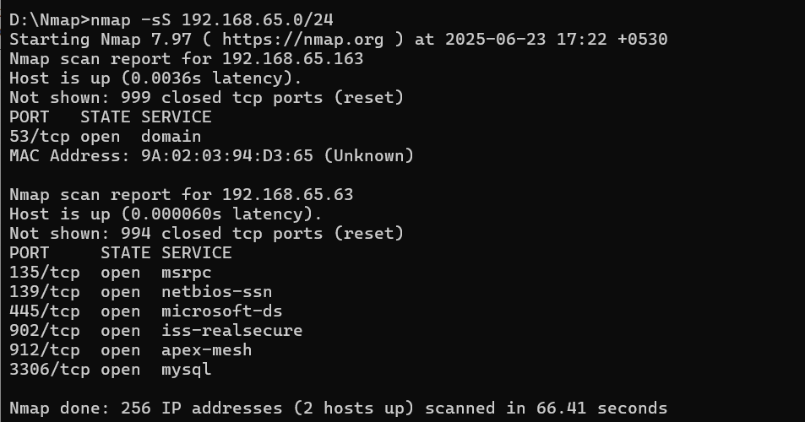 Starting Nmap 7.97 ( https://nmap.org ) at 2025-06-23 17:22 +0530

Nmap scan report for 192.168.65.163

Host is up (0.0036s latency).

Not shown: 999 closed tcp ports (reset)

PORT STATE SERVICE

53/tcp open domain

MAC Address: 9A:02:03:94:D3:65 (Unknown)

Nmap scan report for 192.168.65.63

Host is up (0.000060s latency).

Not shown: 994 closed tcp ports (reset)

PORT STATE SERVICE

135/tcp open msrpc

139/tcp open netbios-ssn

445/tcp open microsoft-ds

902/tcp open iss-realsecure

912/tcp open apex-mesh

3306/tcp open mysql

Nmap done: 256 IP addresses (2 hosts up) scanned in 66.41 seconds

4.

Nmap scan report for 192.168.65.63

Host is up (0.000060s latency).

Not shown: 994 closed tcp ports (reset)

PORT STATE SERVICE

135/tcp open msrpc

139/tcp open netbios-ssn

445/tcp open microsoft-ds

902/tcp open iss-realsecure

912/tcp open apex-mesh

3306/tcp open mysql

5. 

6.

* 135 port service: msrpc often used for tasks like domain management, DNS administration, and Exchange Server management.
* 139 port service: NetBIOS Session Service, which is a legacy protocol used for file and printer sharing in older Windows networks.
* 445 port service: microsoft-ds is dedicated to the Server Message Block (SMB) protocol, which allows you to share resources such as files and printers within a network using TCP.
* 902 port service: iss-realsecure is dedicated to VMware’s vSphere virtualization platform. You use the port to manage your ESXi hosts and the virtual machines (VMs) that run on them.
* 912 port service: apex-mesh used for communication between different APEX relay nodes.
* 3306 port service: mysql databse management system to establish connections between clients and the server.

Other common ports are:

Port 80(HTTP), port 443(HTTPS), port 22(SSH), port 21(FTP), port 23(TELNET), port 25(SMTP), port 53(DNS), port 110(POP3), port 143(IMAP)

7. Open port possess below security risks:

* Unauthorized Access
* Malware Infections
* Denial of Service (DoS) Attacks
* Data Exfiltration
* Data Theft